Mark Kardash

20 August 2023

SDEV350 6380

Professor Carl Eyler

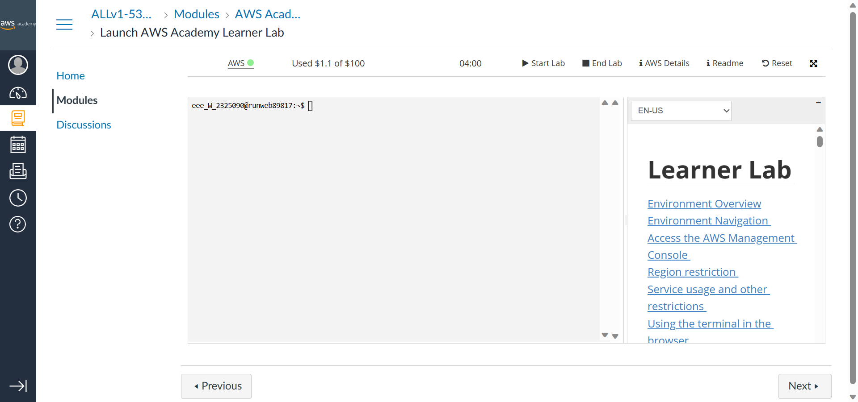

Figure 1: Starting the lab

Here, I have successfully started my Lab in my AWS account.

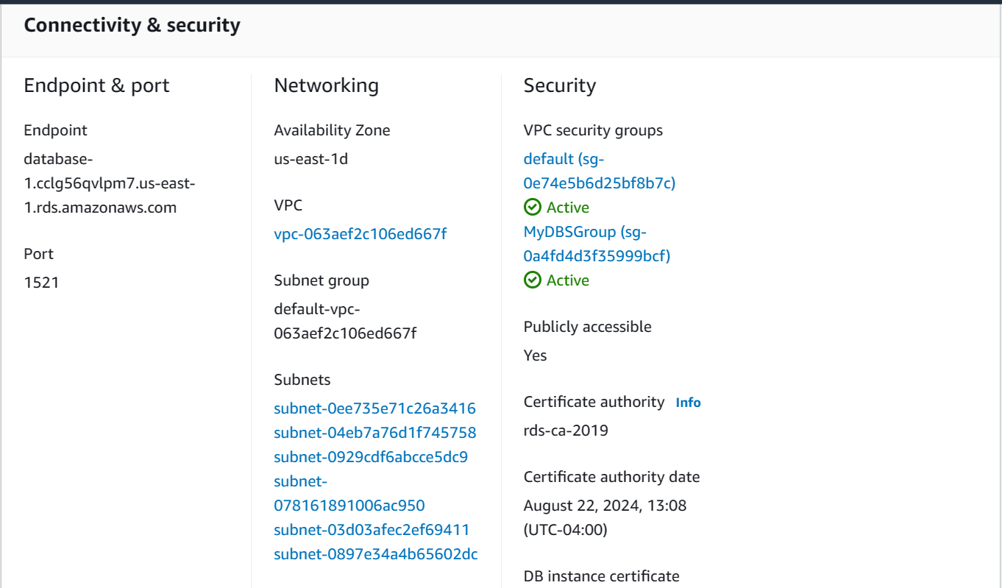

Figure 2: Database status

Information given in the “Connectivity and Security” section indicates the RDS instance has been launched successfully.

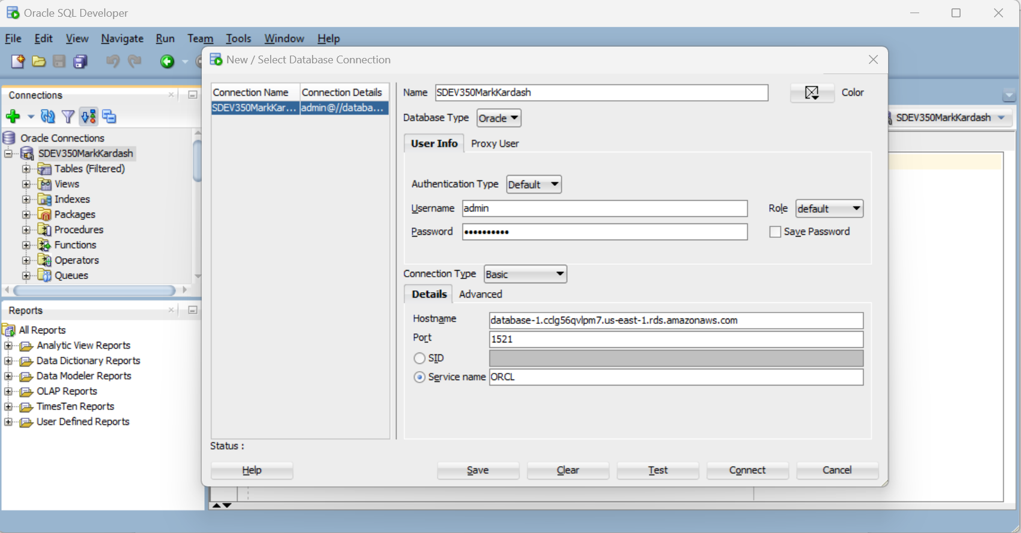

Figure 3: Establishing a connection.

Properties of the connection established are shown in the above image.

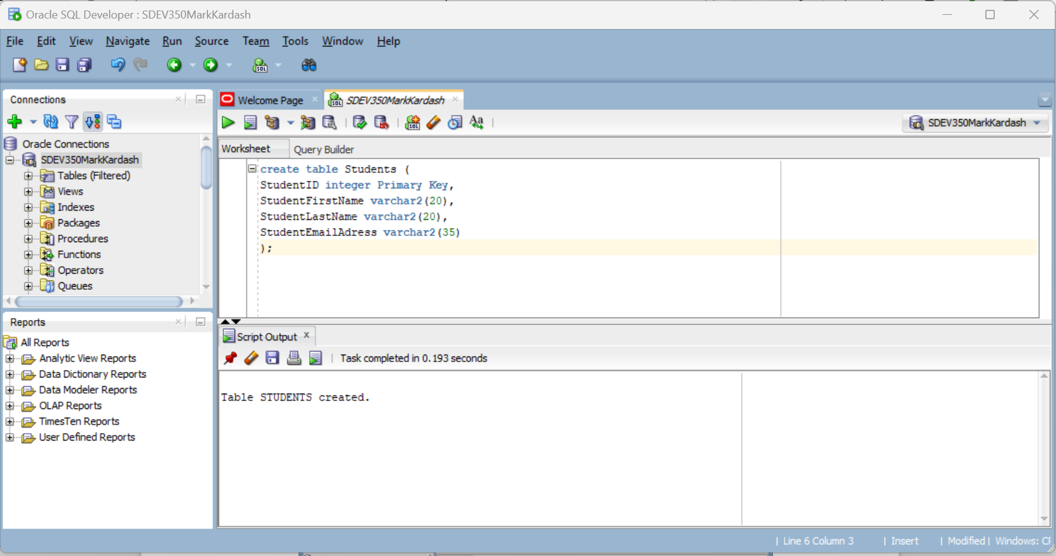

Figure 4: Creating a table

The above image is evidence of the table “Students” (Modeled after the example table “Faculty”) having been created (Changes were discarded after the assignment was completed).